TG-51 Elekta Solid Water Electron Calibration

# Purpose

This procedure details the steps involved in performing a solid water calibration of electrons on CRMC’s Elekta Infinity machines. A spreadsheet performs necessary calculations, including the dose at Dmax in water, but these formulas and other information are provided in the Appendix.

# Steps

## In Elekta-1 Engineers Room

1. A few hours before you perform the calibration, insert the thermometer into the solid water. The thermometer is in a drawer of the cart in the Elekta-1 Engineers Room. The solid water is on top of the cart.

## In Physics

1. When you are ready to perform the calibration, make a copies of *TG-51 Elekta Electrons Cylind Generic.xlsx* and *TG-51 Elekta Electrons PP Generic.xlsx*. Save the copies as *<M/D/YYYY>* *TG-51 Elekta Electrons Cylind.xlsx* and *<M/D/YYYY>* *TG-51 Elekta Electrons PP.xlsx*, respectively.
2. In the copy, change the Elekta number and model name, if necessary. Fill in the date and your initials.
3. Read the pressure using the barometer by the door. Fill in three less than the reading on the spreadsheet.

## In Elekta treatment room

1. Remove the thermometer from the solid water and note temperature. Replace thermometer in cart drawer.

## At Elekta console

1. Open the new Excel sheet on the rightmost computer at the Elekta console. Enter the temperature in the spreadsheet.
2. Attach the electrometer to the white triax cable. Turn on electrometer to allow to warm up.

## In Elekta treatment room

1. Bring the cart from the Engineers Room into the treatment room.
2. Insert the 10×10 cone into the machine and the cutout into the cone.
3. Place the indexing bar at position 2 on table.
4. Put 10 cm of solid water on the table. The easiest way to make 10 cm is with a 6 cm and a 4 cm block.
5. Add the solid water block with the hole for the ion chamber.
6. Insert the cylindrical ion chamber into the solid water. Be sure to remove cap first!
7. Use the tape on the ion chamber box to secure the ion chamber inside the hole. Scoot the box toward the solid water to help secure as well.
8. Attach the ion chamber to the white triax cable that leads into the Engineers Room. Secure the cable on the table using tape.
9. Locate Dmax on the spreadsheet for the energy you are testing. Add that much solid water. For electrons, count 1 cm on the solid water with the hole, toward Dmax.
10. Align the x and y lasers to the marks on the sides of the solid water.
11. Align the z lasers to edge of top of solid water phantom. When the z laser is properly aligned, you should see dust on top of the phantom.

## At Elekta console

1. Zero the electrometer by pressing the ZERO/MODE button.
2. Set the electrometer bias to -300V.
   1. Press the ZERO/MODE button until *Bias* is the bottom setting on the electrometer.
   2. Use the down arrow to set the bias to -300. Ensure that -300 is inside the parentheses as well.
3. Set the electrometer to LOW.
4. Put the middle computer into Service Mode.
   1. Click *Exit*.
   2. Click the Mode icon.
   3. Log in with username and password *service*.
5. Perform the following steps for each 4 MeV and 6 MeV:
   1. Click the wrench icon and then the Deliver Quick Beam icon.
   2. On Radiation tab, set the following:
      1. Modality: x-rays
      2. Energy: 4 MeV or 6 MeV
      3. MLC1: 100 (MLC2 will automatically set to 2 percent more than MLC1)
   3. Click *Load* and then *Confirm*.
   4. Press the ZERO/MODE button on the electrometer.
   5. Press the MV button on the Elekta console to deliver the beam.
   6. On the spreadsheet, record the electrometer reading in the *Charge* table for V(-), V(+), and 1/2V(-). (For the monthly calibrations, we use V(-) to approximate V(+) and 1/2V(-), since the yearly calibration is with V(-).) Ensure that your readings is close to the reading already on the spreadsheet.
   7. Click *Next Beam*.
   8. Repeat steps (c)–(f) for the second reading.
   9. If the first and second readings are not the same, take a third reading.
   10. The monthly test passes if the value is within 2 percent of 1, the yearly test if within 1 percent, and the daily test if within 3 percent. If the test does not pass, repeat steps (c)(j) for this energy for all polarities (instead of approximating using V(-)). Shoot 400 MU between each polarity. If the test still does not pass, adjust the Elekta calibration coefficient for that electron energy.
6. Set up the parallel plate chamber for higher energies (see the photon calibration procedure).
7. Set the electrometer to HIGH.
8. Repeat step 23 for each 9 MeV, 12 MeV, 15 MeV, and 20 MeV.
9. Turn off *then* unplug electrometer.
10. Log out of Service Mode.
11. Remove ion chamber from solid water and unplug triax cable.
12. Put solid water back on cart.
13. Remove cone from machine.
14. Roll cart back into the E-1 Engineers Room.

# Appendix

* PRESSURE (kPa) refers to TPCF.
* *ND,W from K&S* refers to $N_{D,W}^{{}_{ }^{60}{Co}}$.
* Dose at Dmax in H2O refers to $D_{W}^{Q}=M_{raw}×TPCF×P_{gr}^{Q}×k_{R_{50}}^{'}×k_{e_{cal}}×N_{D,W}^{{}_{ }^{60}{Co}}×P_{pol}×P_{ion}×P_{elec}$.

Setup for low-energy electrons (4 MeV and 6 MeV):

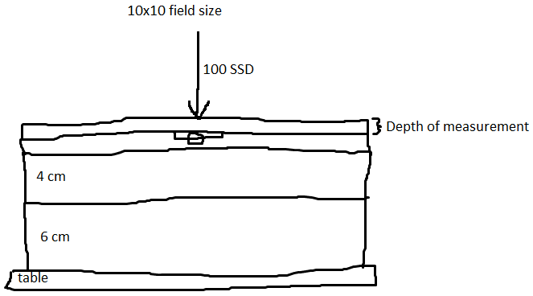

Setup for high-energy electrons (9 MeV, 12 MeV, 15 MeV, and 20 MeV):

